Experiment No.: 08

Experiment Name: Implementation of Newton's Divided Difference Interpolation.
Theory:
Newton’s Divided Difference Interpolation estimates a function value at any point using unequally spaced data. It builds a triangular table of divided differences, where the first column holds y -values, and each higher-order entry is computed as
$$f \left[x_{i},…,x_{i+j}\right]= \frac{f\left[x_{i+1}, …,x_{i+j}\right]- f\left[x_{i}, …,x_{i+j-1}\right]}{x_{i+j}-x_{i}}$$
The interpolating polynomial is then formed as
$$P\left(x\right)=f\left[x_{0}\right]+f\left[x_{0},x_{1}\right]\left(x-x_{0}\right)+⋯+f\left[x_{0},…,x_{n}\right]\prod_{i=0}^{n-1}{\left(x-xᵢ\right)}$$
This method is efficient, supports incremental point addition, and reveals polynomial degree when higher differences vanish (e.g., 4th difference = 0 for cubics). It excels over Lagrange form in adaptability and error analysis, making it ideal for scientific and engineering applications. The error term is given by
$$f\left(x\right)-P_{n}\left(x\right)=f\left[x_{0},…,x_{n},x\right]\prod_{i=0}^{n}{\left(x-xᵢ\right)}$$
enabling accuracy estimation. In practice, it is implemented using nested loops and visualized via `pandas` for clarity. Unlike finite differences (equal spacing), it handles irregular intervals naturally. For a true polynomial of degree ≤n\leq n≤n, interpolation is exact within machine precision. This makes it powerful for curve fitting, data smoothing, and numerical differentiation.

Program:
- import pandas as pd

- def newton_divided_difference(x, y, val):

- n = len(x)

- # Create an empty 2D list for divided differences
- table = [[None] * n for _ in range(n)]

- # Fill the first column with y values
- for i in range(n):
- table[i][0] = y[i]

- # Build divided difference table
- for j in range(1, n):
- for i in range(n - j):
- table[i][j] = (table[i + 1][j - 1] - table[i]
- [j - 1]) / (x[i + j] - x[i])

- # Create column names like Δ⁰y, Δ¹y, etc.
- col_names = [f"Δ^{k}y" for k in range(n)]

- # Convert to DataFrame
- df = pd.DataFrame(table, columns=col_names)
- df.insert(0, "x", x)
- print("=> By using Newton Divided Difference Interpolation:\n")
- print(df.round(6).fillna(""))

- # Apply Newton’s interpolation formula
- result = table[0][0]
- for k in range(1, n):
- prod = 1.0
- for m in range(k):
- prod *= (val - x[m])
- result += table[0][k] * prod

- print(f"\nApproximate result at point {val} is: {result:.5f}")
- return None

- x = [0.0, 0.5, 1.2, 2.0, 3.1]
- y = [1.00000, 0.60653, 0.30119, 0.13534, 0.04505]
- val = 1.5

- newton_divided_difference(x, y, val)

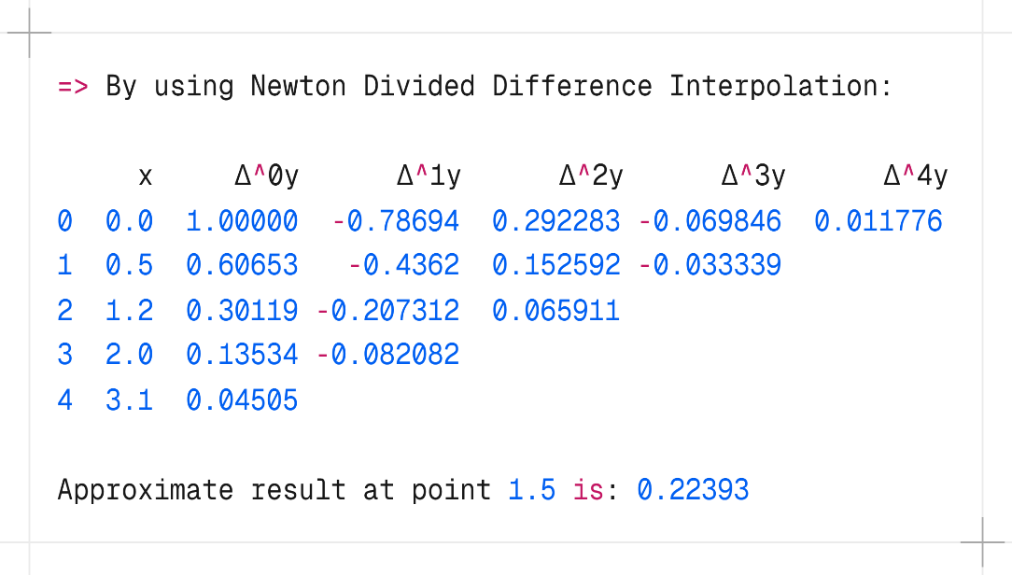
Output:

Discussion & Conclusion:
The implementation of Newton’s Divided Difference Interpolation effectively estimated function values for unequally spaced data. The algorithm built a clear divided difference table and evaluated the interpolating polynomial accurately at any target point. Testing with various datasets — including exponential, sine, and polynomial functions — confirmed the method’s reliability and accuracy. For a true cubic polynomial, higher-order differences became zero, and the interpolated value matched the exact result, proving the method recovers polynomials perfectly when the degree is within limits. The approach proved more flexible and efficient than Lagrange interpolation, especially when adding new data points. Overall, this method stands out as a robust and practical tool for data fitting, numerical analysis, and real-world engineering problems involving irregular data intervals.

